Date: 17.01.2025
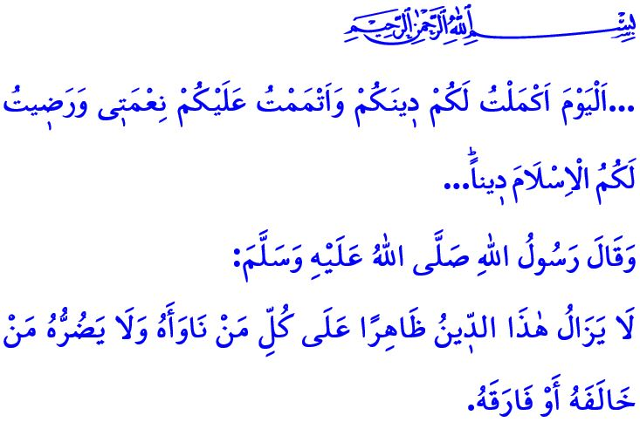
ISLAM: OUR REASON FOR EXISTENCE
Dear Muslims!
In the verse I have recited, our Lord Almighty (swt) states, “...Today I have perfected your faith for you, completed My favor upon you, and chosen Islam as your way...”
In the hadith I have read, our Prophet (saw) says, “A group of people from my ummah will always remain triumphant on the right path and continue to be triumphant (against their opponents). He who deserts them shall not be able to do them any harm.”
Dear Believers!
The greatest blessing bestowed upon us by our Almighty Lord is Islam. Islam is the only religion that began with the Prophet Adam and reached its perfection with our Prophet Muhammad (saw), and with which Allah is pleased. Islam is the religion of mercy and compassion, sent for the guidance and betterment of humanity, as well as for the reconstruction and improvement of the earth. It is a religion of knowledge, wisdom, and understanding that guides the mind, brings peace to the soul, and calms the heart. It is the religion of life that teaches the purpose of our creation and guides us on how to establish a balance between this world and the Hereafter.
Dear Muslims!
It is Islam that transformed all the darkness of the Jahiliyyah period into light. Girls who were buried alive were given life through Islam. Women attained the true dignity they deserved through Islam. The oppressed and marginalized people, whose rights and freedoms were violated, gained their liberation through Islam. As stated in the verse, اِنَّ اَكْرَمَكُمْ عِنْدَ اللّٰهِ اَتْقٰيكُمْۜ “Surely the most noble of you in the sight of Allah is the most righteous among you.”, Islam has proclaimed to the world that superiority lies not in race, gender, status, wealth, fortune, or fame, but in taqwa. Islam has taught humanity the ways of earning halal income, free from lying, deceit, and cheating; free from opportunism, hoarding, and black marketeering; and without infringing upon the rights of others or the public. Islam has taught us to respect our parents, to show care and attention to our families, to uphold the rights of our relatives and neighbors, and to compete in goodness and charity.
Esteemed Believers!
It is unfortunate that we are living in a time when human values and moral virtues are being eroded, and global evils are making the world increasingly uninhabitable. Unfortunately, instead of finding solutions to these negativities, Muslims are becoming alienated from their own identities under the influence of popular culture. All these challenges should never lead us to despair. On the contrary, they should inspire us to work even harder, both in material and spiritual realms, to bring the life-giving principles of Islam to all of humanity. It is Allah’s promise that each person will only have what they endeavored towards, and that the outcome of their endeavors will be seen in their record.
Dear Muslims!
Islam is our past, present, and future. Islam is our reason for existence We are honored and glorified through it. Therefore, let us strive to live Islam not according to our own desires, but as our Almighty Lord has commanded and as the Messenger of Allah (saw) has taught us. Let us incorporate Islamic values into every moment and aspect of life, from clothing, eating and drinking, shopping and trade, to family life and relationships with relatives and neighbors. Let us strive to be good Muslims, exemplary in our faith, worship, and morals, so that others may look to us as a model. Let those who look at us witness the beauty of Islam through our actions and come to love Islam. Let us live Islam so beautifully and authentically, embodying it fully in both our actions and appearance, that those who may seek to harm us will instead find new life through our example. Let us not forget that it is better than the world and everything in it for a person to be drawn to Islam through us, to be guided, and to begin living it in the most beautiful way.
I would like to conclude this Friday’s khutbah with the following testament left to us by our beloved Prophet (saw) in his Farewell Khutbah: “I leave behind me two things. If you follow these, you will never go astray. These are the Qur’an, the Book of Allah, and my example, the Sunnah of His Prophet.”

Ma’idah, 5/3.
Ibn Hanbal, V, 100.
Hujurat, 49/13.
Najm, 53/39,40.
Muwatta’, Qadar, 3. General Directorate of Religious Services

